Ex.No. 2: Implementing TDMA Slot Allocation in GSM.

Objective:
1. To calculate the Time Slot Duration in a GSM TDMA frame by dividing the total frame time into equal time slots. This helps in understanding the time structure of GSM communication.
2. To determine the Frame Utilization (%) based on the number of allocated time slots compared to total available slots. This evaluates the efficiency of TDMA resource usage.
3. To compute the Number of Allocated Time Slots for multiple users in the GSM system. This ensures proper scheduling and interference-free communication.
Objective 1: Matlab Code and Output
clc; clear; close all;
FrameTime = 4.615; Slots = 8;
SlotDuration = FrameTime/Slots;
t = 0:SlotDuration:FrameTime;
figure
subplot(2,1,1)
stem(t,ones(size(t)),'filled')
title('TDMA Time Slot Structure')
xlabel('Time (ms)')
ylabel('Slot Level')
grid on
subplot(2,1,2)
plot(t,ones(size(t)),'-o','LineWidth',1.5)
title('Continuous View of Slot Allocation')

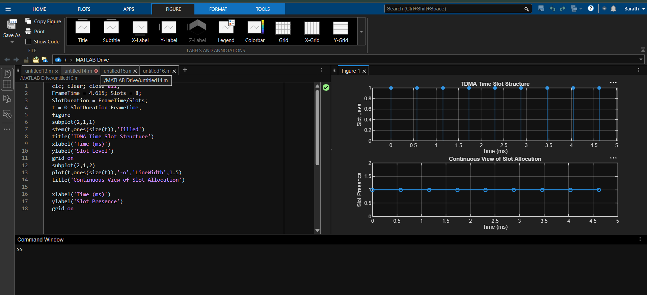

Objective 2: Matlab Code and Output
clc; clear; close all;
TotalSlots = 8;
AllocatedSlots = 6;
FreeSlots = TotalSlots - AllocatedSlots;
Utilization = (AllocatedSlots/TotalSlots)*100;
disp('Frame Utilization (%)')
disp(Utilization)
figure
% Graph 1: Simple Line Plot (SAFE - no bar function)
subplot(2,1,1)
plot([1 2],[AllocatedSlots FreeSlots],'-o','LineWidth',2)
title('GSM Frame Utilization (Allocated vs Free)')
xlabel('Slot Type Index (1=Allocated, 2=Free)')
ylabel('Number of Slots')
grid on
% Graph 2: Pie Chart (SAFE)
subplot(2,1,2)
pie([AllocatedSlots FreeSlots])
title('Slot Distribution in GSM Frame')
legend('Allocated','Free')
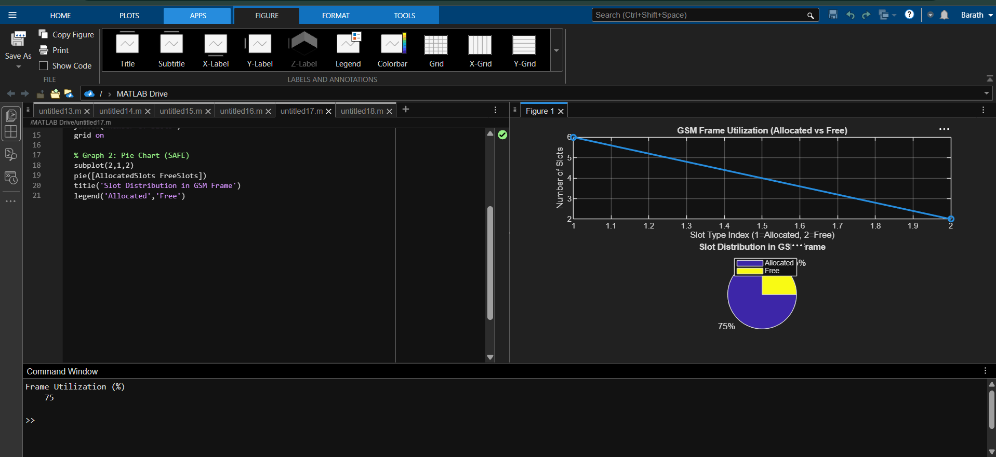

Objective 3: Matlab Code and Output
clc; clear; close all;
Users = 1:8; % Total users
TotalSlots = 5; % Available slots
Alloc = zeros(1,8); % Initialize allocation
Alloc(1:TotalSlots) = 1; % Assign slots to first users
Blocked = 1 - Alloc; % Remaining users blocked
disp('User Wise Slot Allocation')
disp(table(Users',Alloc','VariableNames',{'User','Status(1=Allocated,0=Blocked)'}))
figure
% Graph 1: Allocation per user
subplot(2,1,1)

stem(Users,Alloc,'filled','LineWidth',2)
title('TDMA Slot Allocation per User')
xlabel('User Index')
ylabel('Slot Status (1=Allocated, 0=Blocked)')
ylim([-0.2 1.2])
grid on
% Graph 2: System view (safe alternative to bar)
subplot(2,1,2)
plot(Users,Alloc,'-o','LineWidth',2)
hold on
plot(Users,Blocked,'-s','LineWidth',2)
title('TDMA Slot Utilization Analysis')
xlabel('User Index')
ylabel('Status')
legend('Allocated','Blocked')
grid on
